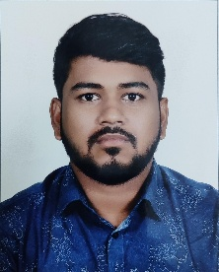

Mr. ARGHYA AKHULI
(Lecturer)
B.Sc. In Medical Laboratory Technology
Mata Gujri College of Allied Health and Paramedical Sciences, Kishanganj
(Mata Gujri University)

Experience:
- 6 Months in Hospital (Lab Technologist)

Research Interests:
  - Hematological changes in infectious diseases
  - Leukemia screening techniques
  - Biochemical markers in diabetes
  - Quality control

Teaching Interests:
  - Pathology
  - Hematology
  - Histopathology
  - Blood Bank
  - Microbiology
  - Parasitology
  - Biochemistry
  - Immunology
  - Clinical biochemistry
  - Human anatomy & Physiology
  - Lab Medicines

Contact Information
  - Email:arghya.mgcoahps@gmail.com

